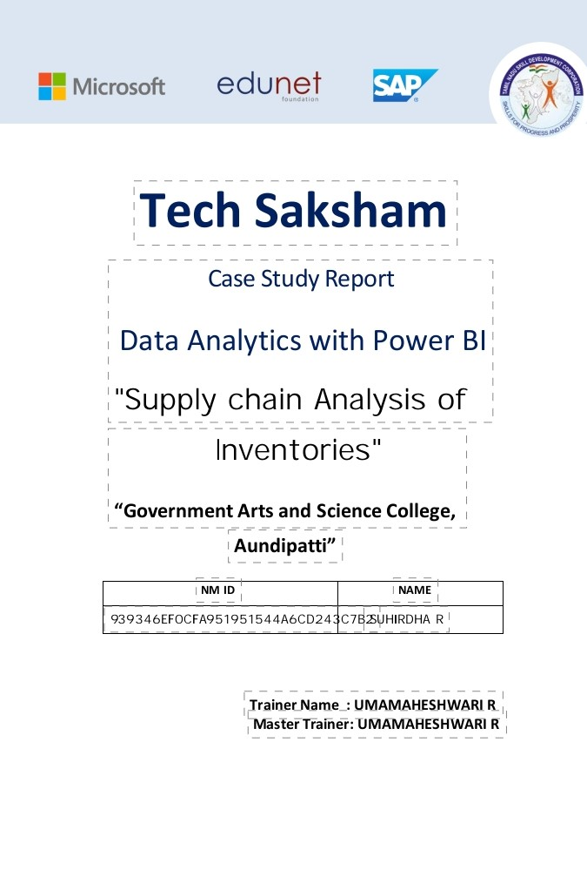 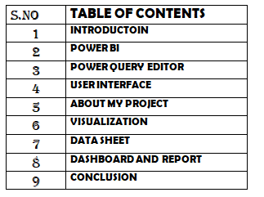 **INTRODUCTION**

POWER BI

Microsoft Power BI is an interactive data visualization software product developed by microsoft with a primary focus on business intelligence. It is part of the microsoft power platform. Power BI is a collection of softwareservice, apps, and connectors that work together to turn various sources of data into static and interacting data visualizations. Data may be input by reading directly from a database webpage, PDF or structured files such as spreadsheets, CSV, XML, ISON, XLSX and sharepoint.

POWER BI DASHBOARD:

Power BI is Data Visualization and Business intelligence tool which helps to converrt data from differeent data source into interactive dashboards and BI reports

POWER BI PROCESS:

Bring data together and increasing the efficiency of creating clear metrics, interactive and user-friendly. .Data Acquistion .Data Enhancement .Data Presentation.

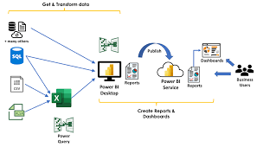

POWER QUERY EDITOR: .Power Query: This is a data connection technology that enables you to discover, connect, combine, and refine data across a wide variety of sources.

SOFTWARE REQUIREMENT: .Power BI Desktop: This is a Window application that you can use to create reports and publish them to Power BI. .Power BI Service: This is an online SaaS(Software as a Service) service that you use to publish reports, create new dashboards, and share insights

.Power BI Mobile: This is a mobile application that you can use to access your reports and dashboards on the go. .Power Query is a data transformation and data preparation engine. Power Query comes with a graphical interface for getting data from source and a Power Query Editor for applying transformations. Because the engine is available in many products and services, the destination where the data will be stored depends on where Power Query was used. Using Power Query, you can perform the extract, transorm, and load(ETL) processing of data.

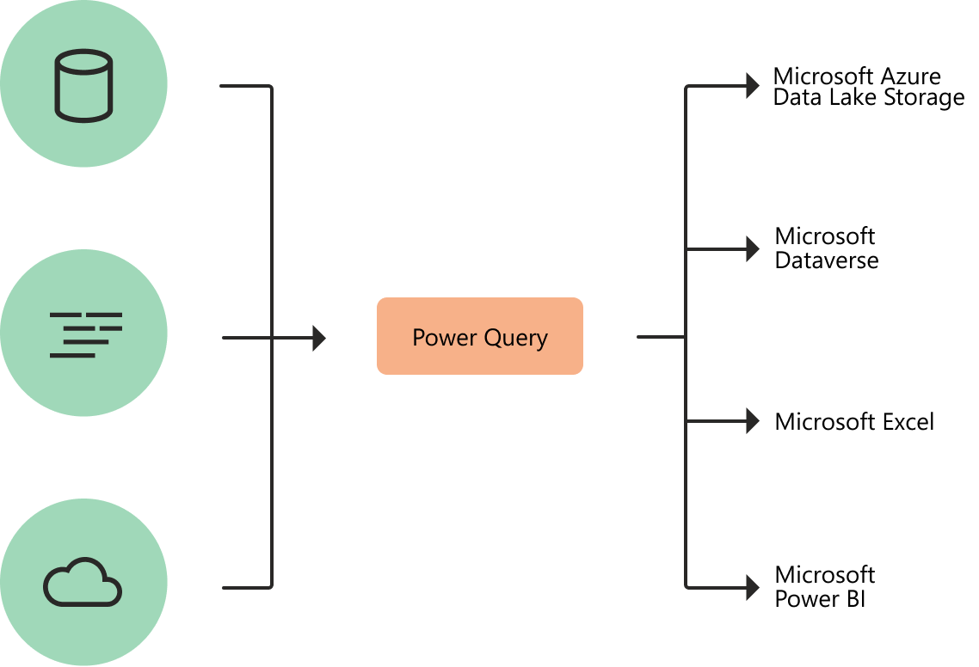

The Power Query Editor is the primary data preparation experience, where you can connect to a wide range of data sources and apply hundreds of different data transformations by previewing data and selecting transformations from the UL.

These data transformation capabilities are common across all data sources, whatever the underlying data source limitations. When you create a new transformation step by interacting with the components of the Power Query interface, Power Query automatically creates M code required to do the transformation so you don't need to write any code. Currently, two Power Querry experiences are available:

POWER QUERY ONLINE- Found in integrations such as Power BI dataflows, Microsoft power platform dataflows, Azure Data Factory wrangling dataflows, and many more that provide the experience through an online web page.

.POWER QUERY FOR DESKTOP- Found in integrations such as Power Query for Excel and Power BI Desktop.

NOTE: Although two Power Query experiences exists, they both provide almost the same user experience in every scenario

. TRANSFORMATION: The transformation engine in power Query includes many prebuilt transformation functions that can be used through the graphical interface of the Power Query Edotpr. These transformations can be as simple as removing a column or filtering rows, or as common as using the first row as a table header. There are also advanced transformation options such as merge, append, group by, pivot, and unpivot.

All these transformation are made possible by choosing the transformation option in the menu, and then applying the options required for that transformation. The following illustration shows a few of the transformations available in Power Query Editor.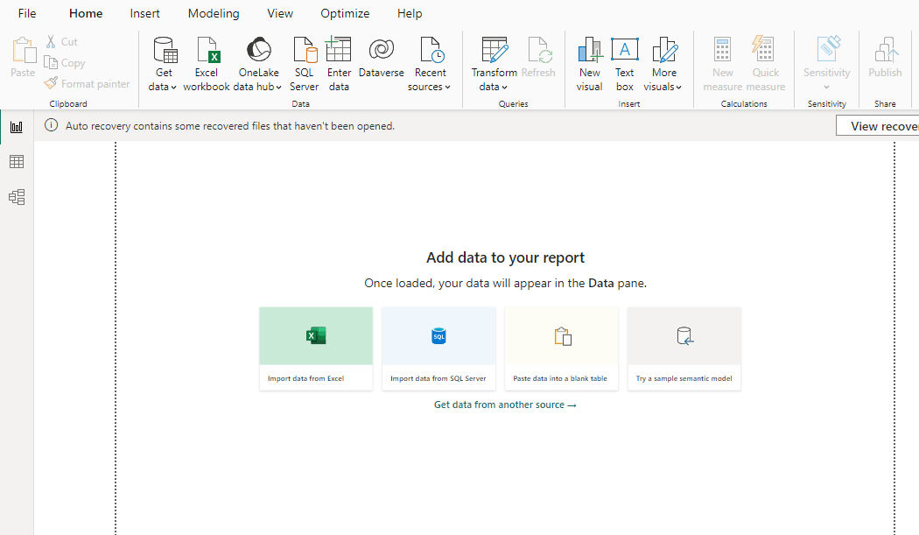

USER INTERFACE:

THE RIBBON:

At the top we have the familiar Microsoft Ribbon. Just like the ribbons in Microsoft Excel and Word and Powerpoint, the Powerpoint, the Power BI ribbons is filled with tools split up into different tabs.

RIBBON TABS: The HOME tab has tools for adding data sources, accessing power Query Editor (used for cleaning and transforming data) via the ''Transform data'' buttons, and adding in visuals and more.

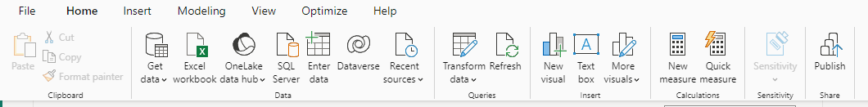

The MODELING tab lets us create DAX measures, or even new coloumnsand tables, and also lets us set up a security model if we need some users to only see some.



The INSERT tab tab lets us insert different visual, text boxes, buttojns, shapes and images.

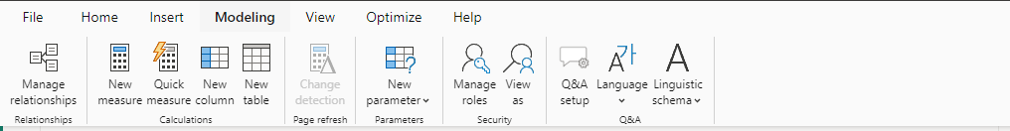

The VIEW tab lets us set a theme for our reports, set up mobile layouts, and access other panes that don't show up by default.



The OPTIMIZE tab has tools to check the efficiency of our reports... as in if they are loading really slow, we can analyze what parts of the report are loading

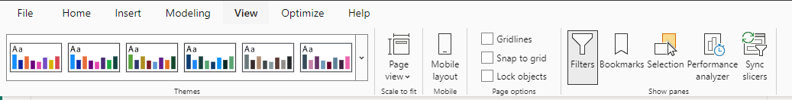

The HELP tab has links to things like Microsoft forums Power BI blog which has new about new features.

The EXTERNAL TOOLS tab is where 3rd-oarty tools live. There are only a few of these okay' by Microsoft, and if you haven't download one, this tab doesn't show up.

PANES:

One the right side of the Power BI interface are 3 panes that appear by default.

The DATA pane is where we see the tables and columns of data we've added.

The VISUALIZATION pane is where we can choose what visual we want to make, and it also has formating tools. The FILTERS pane is where we can create filters and control what data is makaing it from our data to the canvas.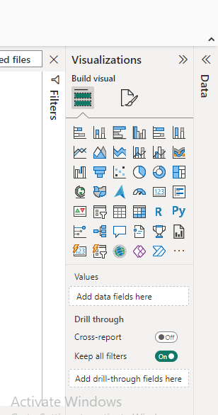.

ABOUT MY PROJECT: Supply Chain Management(SCM) is the handling of the entire production flow of goods and services that include all process for converting raw materials into final products. It involves the active streamlining of a business's supply side activities to maximize customer value and gain a compose advantages in the market.

Supply Chain Management practice depends heavily on industrial engineering, systems engineering, cooperation management , logistics, procurement information technology and marketing, and strives for an integrated approach. It is the broad range of control and execute a produced flow from materials to production to distribution in the most economical possible.

Supply Chain Management encompasses the planning and management of all activities involved in sourcing. Procurement, conversion, and logistics management activities. Importantly, it also includes coordination and collaboration with channel partners, which can be suppliers, intermediaries, third-party service providers, and customers. In essence, Supply Chain Management integrates supply and demand management within and across companies.

DATA SHEET

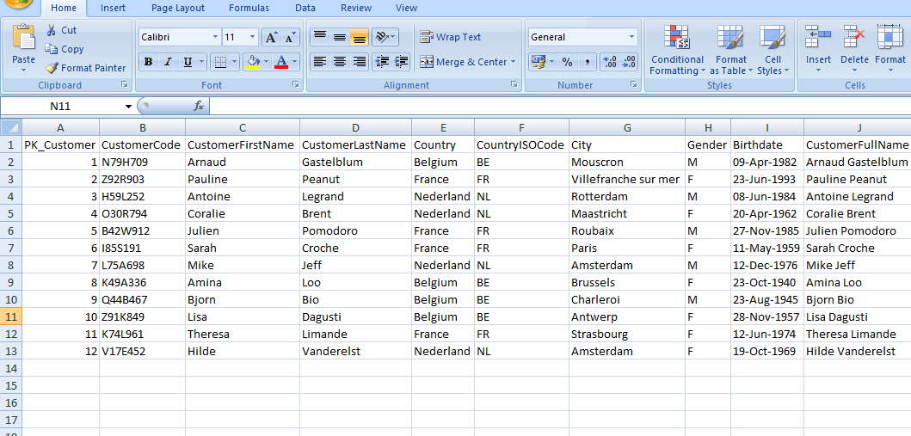

SUPPLY CHAIN ANALYSIS OF INVENTORIES(Data Sheet) in excel format.

VISUALISATION: Funnel chart

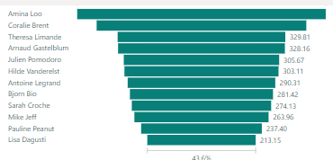This graph represent the total amount and the customer full name,

PIE CHART AND GAUGE CHART

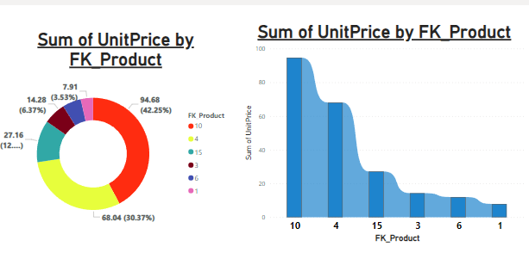

The pie chart represent the product name and product unit price The gauge chart show product name and their quantity

RIBBON CHART and COLUMN CHART

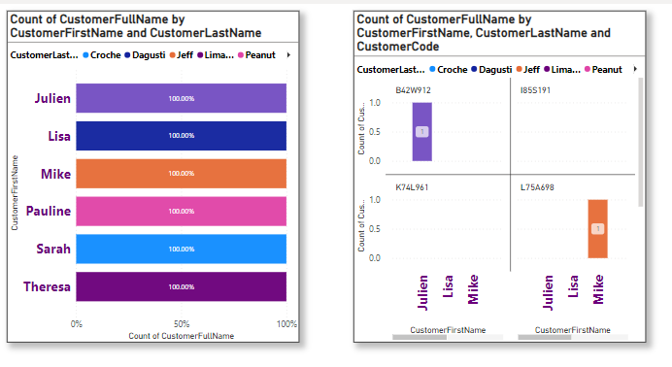

The ribbon chart represent city, country and genders but the column chart represent the country and city alone.

TREE CHART

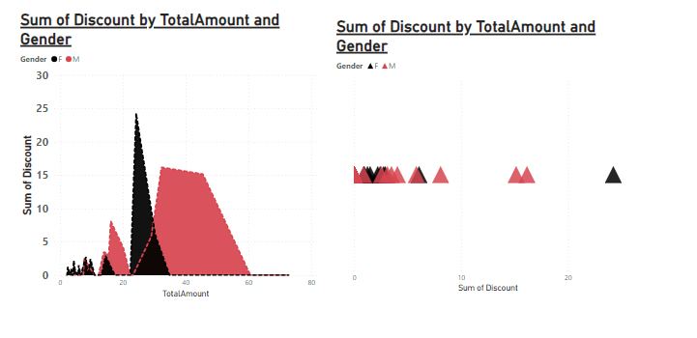

Here The chart show the customer code and customer ISO code and the product .

WATER FALLS CHART AND COLUMN CHART

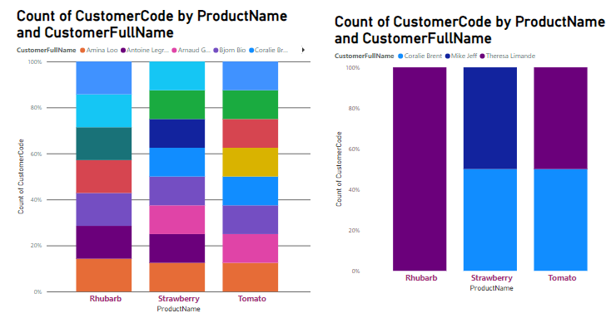

Both charts represent gender and year in various format

DOUGHNUT CHART

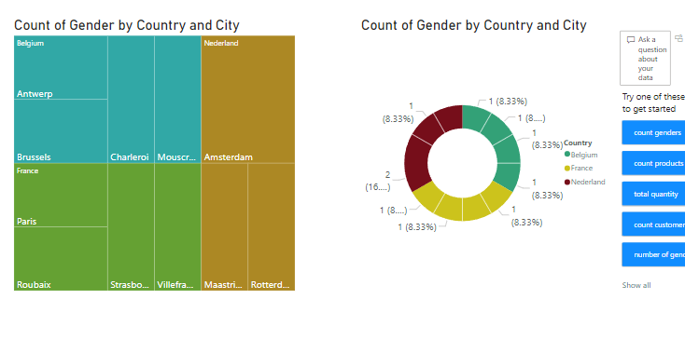

Its show the graph between customers first and last names.

DASHBOARD AND REPORTS:

SUPPLY CHAIN ANALYSIS

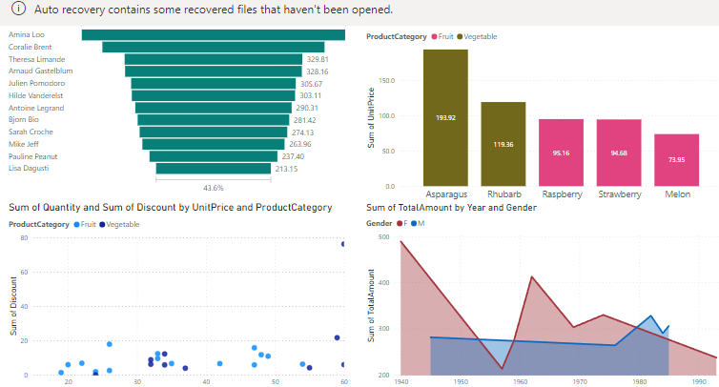

REPORTS: Power BI numerous benefits for project tracking. One of the main advantages is its ability to consolidate data from multiple sources, such as project management tools, financial systems, and spreadsheets. This allows project managers to have a holistic view of the project, making it easier to identify trends, patterns, and anomalies. Power BI's advanced visualizations enable the creation of intuitive dashboards , making it effortless to track project progress at a glance.

Furthermore, Power BI's intteractive features allow users to explore and drill into the data, gaining deeper insights into the project's performance. Another benefit of using Power BI for project tra king is its ability to automate data refreshes. With power Power BI, project managers can set up scheduled refreshes to ensure that the data is always up to date.

This eliminates the need for manual data updates and reduce the risk of using outdated information for decision-making. In addition, Power BI offer a wide range of collabration features that enhance team collabration and communication.

Project teams can easily share dashboards and reports with stakeholders, enabling real-time annotations to specific data points, facilitating discussion and improving the overall project tracking process.

CONCLUSION: Microsoft Power BI is an indispensable tool in the realm of business intelligence. Its robust features, ease of use, and ability to transform raw data into actionable insights make it a top choice for organizations worldwide. As you wrap up you Power BI project, consider the following key points:

DATA CONNECTIVITY: Power BI's extensive connector library allows seamless integration with various data sources, including google Analytics, SQL databse, and more.

CUSTOM VISUALISATION: Leverage Power BI's pre-designed visualisations to create interactive reports tailored to your specific needs. Additionally, explore third-party solutions like FluenPro's report packs for enhanced intelligence and analytics.

PERFORMANCE OPTIMIZATION: The columnar database engine within power BI significantly improves performance by compressing large datasets, making it an effect choice for data modeling.

<Https://github.com/Suhirdhac1s23226/Suhirdha-power-BI>